Psalm 23
(A Psalm of David.) The LORD is my shepherd; I shall not want.
He makes me to lie down in green pastures: He leads me beside the still waters.
He restores my soul: He leads me in the paths of righteousness for His name's sake.
Yea, though I walk through the valley of the shadow of death, I will fear no evil: for You are with me; Your rod and Your staff comfort me.
You prepare a table before me in the presence of mine enemies: You anoint my head with oil; my cup runs over.
Surely goodness and mercy shall follow me all the days of my life: and I will dwell in the house of the LORD forever.

From Psalm 130
Out of the depths I call to You, O God; You hear me fully when I call. God is with me, I have no fear. I was hard-pressed, about to fall; God came to my help. God, You are my strength and my courage. I will not die, but live, and yet tell of the deeds of God. I thank You for having heard me; O God, be my deliverance.
Kriyat Shem
Although this child left this world before they lived with us, they will always live on in our memory. We shall remember this child by the name [name]

Birkat Hagomel

בּרוּךְ אַתָּה יְיָ אֱלֹהֵינוּ מֶלֶךְ הָעוֹלם הַגּוֹמֵל לְחַיָּבִים טוֹבוֹת שֶׁגְּמָלַנִי כָּל טוֹב
Baruch atah Adonai eloheinu melech ha’olam, hagomel lechayavim tovot, shegemalani kol tov.
Blessed are You, Adonai our God, ruler of the universe, showing goodness to us beyond our merits, for bestowing favor upon me.
[response]
מִי שֶׁגְּמָלֵךְ כָּל טוֹב הִיא תִגְמְלֵךְ כָּל טוֹב. סֶלָה. אָמֵן.
Mi shegemalech kol tov, he yigmalech kol tov. Selah. Amen.
May the One who has shown you every kindness, ever show kindness to you. Selah. Amen.

Mi Shebeirach;

May God who blessed our ancestors, Abraham, Isaac, and Jacob, Sarah, Rebekah, Rachel, and Leah, grant refu’at hanefesh urefu ‘at haguf, a complete healing of body and spirit to [parents], abundant blessings from loved ones, and an awareness of God’s presence with them in their pain. As for the baby that was not to be, shelter this spirit, O God, in the shadow of Your wings for You are a gracious and loving God. Guard our coming and our going, grant us life and peace, now and always, for You are the Source of life and peace. May we as a holy community support and love our friends in times of pain as well as times of joy. And as we have wept together, so may we soon gather to rejoice.
Amen.

From Psalms 147 & Bereavement Liturgy
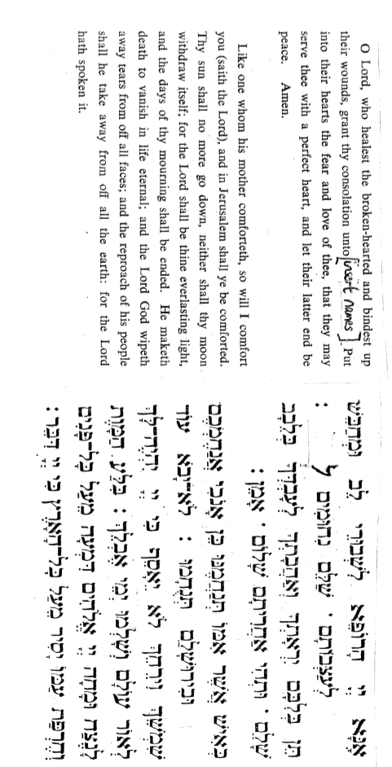

Resources used include

http://www.kveller.com/article/a-synagogue-ritual-for-miscarriage/
http://www.ritualwell.org/ritual/funeral-service-miscarriage-jewish-mourning-story
https://www.rabbinicalassembly.org/sites/default/files/public/halakhah/teshuvot/19912000/dickstein_stillbirth.pdf
http://www.ritualwell.org/ritual/prayer-after-miscarriage-or-stillbirth
Rabbi Chai Levy, Rabbi Stephanie Dickstein, Rabbi Sandy Eisenberg Sasso

